Warning Signs of a Stroke
- Sudden numbness or weakness of the face, arm, or leg, especially on one side of body
- Sudden confusion
- Sudden difficulty speaking or understanding, slurred speech
- Sudden blurred vision or loss of vision
- Sudden difficulty walking, dizziness, loss of balance or coordination
- Sudden severe headache with no known cause
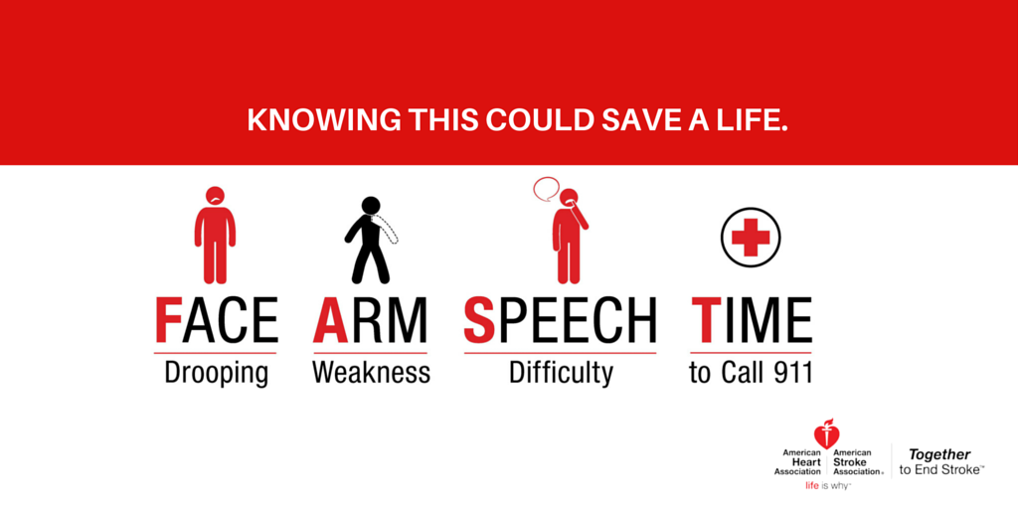
https://www.wakemed.org/neurosciences-stroke-symptoms

Difference between Ischemic Stroke and Hemorrhagic Stroke
- Ischemic: sudden blockage of a blood vessel in the neck or brain, causing brain tissue to be deprived of oxygen (87% of total strokes are caused by thrombus)

- Hemorrhagic: blood vessel bursts in brain (10% of stroke but higher death rate)

