|  |  |
| --- | --- |
|  |  |

Guillain-Barré

Syndrome

Also known as…

* Acute Idiopathic Neuropathy
* Infectious Polyneuritis
* Landry’s Syndrome

What is it?

[Grab your reader’s attention with a great quote from the document or use this space to emphasize a key point. To place this text box anywhere on the page, just drag it.]

An acute inflammatory condition involving the spinal nerve roots, peripheral nerves, and—in some cases—selected cranial nerves. The body’s immune system attacks nerves.

Symptoms

An acute inflammatory condition involving the spinal nerve roots, peripheral nerve roots, and—in some cases—seleceted cranial nerves

*Pain & tenderness of muscles

*Decreased deep tendon reflexes

As disease progresses…

*Motor Weakness

*Paralysis of limbs

*Muscle Atrophy & severe fatigue

*Sensory Loss

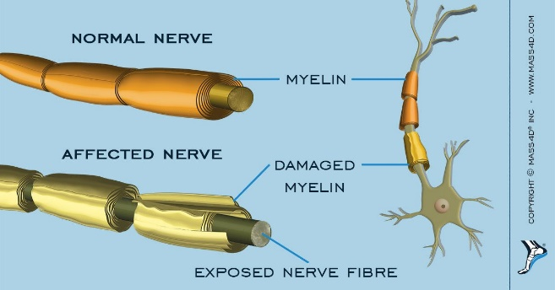

How & who?

[Grab your reader’s attention with a great quote from the document or use this space to emphasize a key point. To place this text box anywhere on the page, just drag it.]

* Improvement of Activities of Daily Living
* Implementation of Adaptive equipment or techniques
* Positing & splinting to prevent contractures & deformity
* Strength
* Range of Motion (ROM)
* Grooming, Self-care, & more

Caused by a viral illness, immunization, or surgery and may affect BOTH sexes at ANY age

***How can Occupational Therapy Help?!***